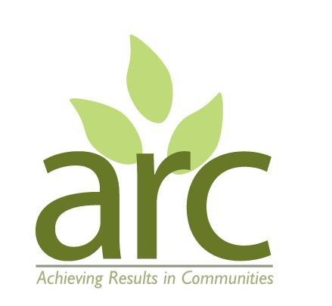

ARC Director / Trustee Recruitment 2026

ARC Director (future Trustee) Role Description
ARC (Achieving Results in Communities) are looking to recruit Directors (future Trustees) from a range of backgrounds, life stages and skills to join our existing Board of five.
ARC Background
ARC was established as a Community Interest Company (CIC) in 2011. Our mission is to improve the health and wellbeing of individuals, communities and the environment in Warwick District through nature connection activities. We engage over 650 adults and children each year and maintain eight woodland and garden sites.
ARC has 9 part time staff (roughly 2 FTE) and an annual turnover of around £120,000. We have no office, most staff delivering sessions at outdoor sites and carrying out admin work from home. We are leaseholders of Foundry Wood Community Woodland, CV31 6AF.
To learn more about our themes, projects and other activities please visit www.arccic.co.uk and www.eventbrite.co.uk/o/arc-achieving-results-in-communities-84849003323.
ARC’s plans over the next 3 years include:
- Transition from a CIC to a CIO via the Charity Commission
- Refine our Strategy in readiness for the Charity application process
- Further develop our three delivery areas: Adult Wellbeing; Community Gardening; and Children and Families
- Enhance our local networking / influencing role around themes of Wellbeing and Nature
- Develop our individual giving, corporate donations, and other income streams
Roles and responsibilities of a Director / Trustee:
- Meet four times a year - meetings typically 1.5 hours
- Oversee the running and governance of ARC
- Review accounts and ensure financial integrity of the organisation
- Advocate for ARC and contribute to public events or activities where possible.
Essential Director / Trustee characteristics;
- Passion and commitment to fulfilling ARC’s mission
- Availability to attend quarterly board meetings (early evenings in Leamington or Warwick)
- Ability to apply clear logical thinking and creativity to developing our strategy
- Confidence to contribute to team discussions
- Resident of Warwick District
Desirable skills and experience include:
- A good understanding of governance, gained either as a Trustee of another charity, a director of a company, or as a manager who has worked with Boards
- Ability to represent groups we aim to engage with, including:
  - geographical communities where we work;
  - lived experience of long term mental or physical health issues, neurodiversity or disability;
  - those from the global majority;
- Experience around income diversification, particularly individual and corporate giving
- Ability to represent ARC and network around our Wellbeing and Nature themes.
Benefits for a Trustee:
- Gain satisfaction from helping a small organisation develop.
- Work with like-minded people and feel more connected to your community.
- Contribute to tangible improvements in people’s lives and local green spaces
- Develop new skills and experience.

Application Process
Please complete the online application form here https://forms.gle/FqnsAzL9XMAuVupo7 and also send a short CV or summary of your work / voluntary experience (1-2 pages) to kath@arccic.co.uk.
Please also email kath@arccic.co.uk with any further questions or queries regarding the role.

