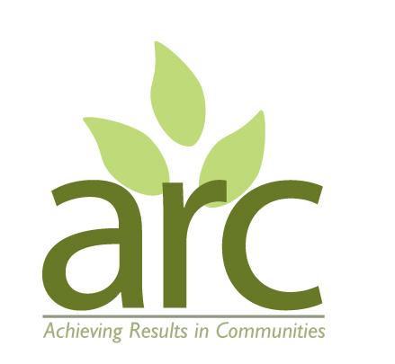

**Part-Time Woodland Wellbeing Session Facilitator**

**Location:** Tallis Wood, Radford Semele.

**Start Date:** September 2025

**Hours:** Average 7 hours per week over 7 weeks September to October 2025

**Contract:** Fixed term – 2 months with likelihood of extension depending on funding.

**Pay:** £20 per hour

We are seeking a reliable and empathetic co-facilitator to help deliver our upcoming Woodland Wellbeing course of 7 weekly sessions, 10am til 3pm. The course is aimed at people struggling with long term mental or physical health conditions, loneliness or addiction recovery. The facilitators create opportunities for peer to peer sharing, deep nature connection, re-framing perspectives on mental health and accessing new volunteering opportunities and support services.

Courses typically run 3 to 4 times per year outside of school holidays. We anticipate the role will be extended once additional funding is confirmed. Dates of future courses are available on request.

**Role:**

* 7 sessions - Wednesdays 3rd September to 15th October 2025, 9.15 am til 3.15pm including set up/pack down;

* Co-facilitate sessions including mindfulness, group sharing, nature connection and woodland maintenance activities;

* Support participants in building confidence, skills, and connection through nature;

* Shop for and prepare a simple one-pot vegetarian /vegan lunch for participants (recipes, cookware and support provided);

* Assist in the collection of case studies for evaluation / reporting purposes.

* Assist with local outreach, and communications, using personal / home office equipment.

You will be delivering the sessions alongside one current and experienced facilitator who can support you in learning the role and building confidence in the activities. You will be part of a wider team of ARC staff with opportunities for sharing experiences and engaging in other areas of our work.

**Ideal Candidate:**

* Has lived experience of a long term mental or physical health conditions, loneliness or addiction recovery, or has experience of working with / caring for people with these life experiences.

* Feels comfortable using their experiences, empathy and understanding to help others and to inspire hope and recovery.

* Has excellent interpersonal skills and the ability to build trusting and productive relationships with a range of people.

* Is organised, punctual, self-motivated, and comfortable working outdoors in all weather conditions;

* Has experience (paid or voluntary) in community work, facilitation, or wellbeing settings.

* Has sound administrative skills and access to personal / home office facilities.

This role offers meaningful and fulfilling work in a supportive environment, with potential for growth if funding is renewed. There may be optional additional work available supporting ARC administration, fundraising, networking, governance, strategy etc. Please indicate your wider skills and experience if you are interested in this work.

ARC is committed to reflecting the diversity of the UK across the company and its work. We are currently under-represented in our staff team by people from a global majority ethnic backgrounds, and/or those identify as D/deaf, disabled, LGBTQ+. We actively encourage applicants from these backgrounds.

**How to Apply:**

Please send your CV and cover letter outlining your suitability to the role to: [info@arccic.co.uk](mailto:info@arccic.co.uk)

**Application deadline: 5pm Friday 13th June**.

Interviews will be 19th or 20th June.