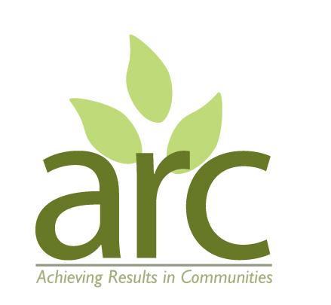

**Part-Time Community Gardening Session Facilitator**

**Location:** Lyttelton Road Community Garden, Warwick

**Start Date:** July 2025

**Hours**: Average 15 hrs /month.

**Contract:** Fixed term – 9 months with possibility of extension depending on funding. Freelance or payroll to be discussed.

**Pay:** £20 per hour

ARC (Achieving Results in Communities, CIC) are seeking an outgoing, reliable, and community-focused individual to facilitate gardening sessions at a newly established community garden in Warwick. This is an excellent opportunity for someone who is passionate about wildlife gardening, enjoys working with people of all ages and backgrounds, and values inclusive, nature-based community spaces.

**Role:**

* 5 sessions per month, 3 hours per session (4 Fridays + 1 Saturday)

* Fridays 10 am–12 pm (plus 1 hour setup/pack down)

* One Saturday morning a month 10 am–12 pm (plus setup/pack down)

* Deliver engaging, inclusive, and practical gardening sessions

* Support participants in building confidence, skills, and connection through nature

* Assist with local outreach, and communications using personal / home office equipment.

You will be delivering the sessions alone, but with oversight and support from the current facilitator who has established strong connections with local partners and funders. You will be part of a wider team of ARC staff with opportunities for sharing experiences and engaging in other areas of our work.

**Ideal Candidate:**

* Has experience of wildlife gardening and / or growing food;

* Enjoys working with people in a friendly and inclusive manner;

* Is organised, self-motivated, and comfortable working outdoors in all weather conditions;

* Has experience (paid or voluntary) in community work, facilitation, or wellbeing settings.

* Has some knowledge of the local community.

* Has sound administrative skills and access to personal / home office facilities.

This role offers meaningful and fulfilling work in a supportive environment, with potential for growth as the project develops. There may be optional additional work available supporting ARC administration, fundraising, networking, governance, strategy etc. Please indicate your wider skills and experience if you are interested in this work.

ARC is committed to reflecting the diversity of the UK across the company and its work. We are currently under-represented in our staff team by people from a global majority ethnic backgrounds, and/or those identify as D/deaf, disabled, LGBTQ+. We actively encourage applicants from these backgrounds.

**How to Apply:**

Please send your CV and cover letter outlining your suitability to the role to: [info@arccic.co.uk](mailto:info@arccic.co.uk)

**Application deadline: 5pm Friday 13th June**.

Interviews will be 19th or 20th June.