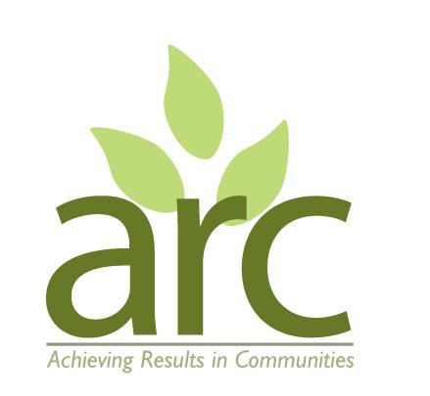
Achieving Results in Communities (ARC) Community Interest Company

Health and Safety Policy

ARC recognises and accepts its health and safety duties for providing a safe and healthy working environment (as far as is reasonably practicable) for all its workers (paid or volunteer) and other visitors to its workplaces and projects under the Health and Safety at Work Act 1974, the Fire Precautions (Workplace) Regulations 1997, the Management of Health and Safety at Work Regulations 1999, other relevant legislation and common law duties of care.

ARC and its employees commit to ensuring this policy is implemented and monitored, and to report regularly on its effectiveness.

A detailed Risk Assessment is created and carried out for each of ARC’s projects and locations – including any Covid-19 requirements based on up to date Government Guidance. ARC does not have a main workplace but carries out project work at various locations.

ARC commits to:

- preventing accidents and cases of work-related ill health by managing the health and safety risks at our places of operation
- providing clear instructions and information, and adequate training, to ensure employees and volunteers are competent to do their work
- engage and consult with employees and volunteers on day-to-day health and safety conditions
- implement emergency procedures such as evacuation in case of fire or other significant incident
- maintain safe and healthy working conditions, provide and maintain plant, equipment and machinery, and ensure safe storage/use of substances
- report any serious accidents under the RIDDOR (Reporting of Injuries, Diseases and Dangerous Occurrences Regulations)
- carry out risk assessments to identify risks in all our places of operation and project activities.

ARC will comply with its duty to ensure, as far as is reasonably practicable, the health, safety and welfare at work of its workers and of visitors and volunteers by:

- making workplaces and projects and safe and without risks to health
- ensuring buildings (including sheds) are safe and that safe systems of work are set and followed
- ensuring equipment and substances are moved, stored and used safely
- giving workers and volunteers the information, instruction, training and supervision necessary for their health and safety
- ensuring the wellbeing of workers who habitually use display screen equipment for a significant part of their normal work

Any accidents should be entered in the Accident Report Book located on site with the first aid kit and reported via email to the designated Health and Safety Officer. If required an Incident form will also be completed and provided to the Health and Safety Officer.

The Company’s designated Health and Safety Officer is Lucie Cox - Lucie@arccic.co.uk

This policy will be reviewed bi-annually by the Directors. All aspects of the policy are monitored as an ongoing practice.

Name: Kath Pasteur, ARC Director
Signed: 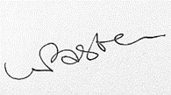

Date: 08/06/2025

Date of next Review: May 2027

