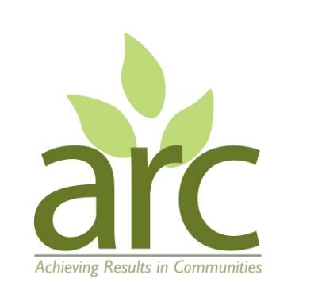
Achieving Results in Communities (ARC)
Community Interest Company

Environmental Policy

ARC Policy Statement

Nature is at the heart of everything we do. We believe that nature has the potential to transform communities and individuals for the better. ARC supports people to engage with the natural environment and enjoy the outdoors in order to boost their mental and physical wellbeing.

We know that people who spend time in nature are happier and healthier. That’s why we adopt a ‘nature and people first’ approach to our work. Whether it’s through our adult wellbeing sessions, tree planting with children or creating urban gardens and woodlands, ARC actively seeks to conserve, protect and restore the natural environment whilst boosting wellbeing.

At ARC, we believe that nature has powerful potential to tackle some of our most pressing social challenges. If we look after nature, nature will look after us. Embracing nature is a proven, low carbon approach to improving wellbeing.

Our environmental policy is a set of guidelines which helps us minimise our footprint whilst maximising our social and community impact. We carry out environmental impact assessments to help us understand and mitigate any potentially harmful activities.

Beyond ‘net neutral’ to ‘net positive’

ARC believes we should go beyond the concept of “do no harm”. That means leaving the open spaces where we work in a better state than when we found them - but it also means having a positive impact on the lives of the people we work with.

Just as we strive to operate as responsible stewards of the environment, so we strive to enrich the lives of our staff, volunteers and clients. That’s what we mean by “net positivity”: everything we do has a holistically positive impact.

People and community are at our heart. We believe doing good within society is a crucial part of sustainability. Building positive relationships with people and having positive effects on their lives are just as important as creating a better natural environment.

We aim to:

- seek to better understand the impact our activities have on the environment
- safeguard the environment in all our activities
- continually improve our environmental performance
- conserve energy, reduce consumption of raw materials and to reduce waste
- where possible, use renewable natural resources and conserve non-renewable resources through efficient use and careful planning
- minimise the creation of waste, and wherever possible recycle materials and encourage others to do likewise
- promote sustainable and positive environmental action through our own activities and
those of our contractors, partners, stakeholders and clients
- where possible, use suppliers who share our vision for the environment, e.g. avoid Amazon
- minimise the risk of environmental damage by employing safe technologies and operating procedures
- disclose to our partners, stakeholders, clients and the relevant authorities any incidents relating to our operations that cause environmental harm
- ensure that all staff and contractors are aware of their environmental responsibilities as laid out in these principles
- carry out regular self-evaluation and environmental audits of our activities to ensure compliance with these policies
- source products locally / from independent outlets where feasible and still cost effective, rather than buying from big companies or buying online.

We will take these specific actions in the following areas:

Paper, office and cleaning supplies

- minimise the use of paper in the office
- reduce packaging as much as possible
- use recycled and recyclable paper products
- reuse and recycle all paper and equipment where possible
- evaluate if renting/sharing is an option before purchasing equipment
- evaluate the environmental impact of any new equipment we intend to purchase
- favour more environmentally friendly and efficient equipment wherever possible
- only use environmentally-friendly cleaning products both in the office and during outside activities
- only use licensed and appropriate organisations to dispose of waste

Energy and water

- reduce the amount of energy used as much as possible
- lights, electrical equipment and heating will be switched off when not in use
- the energy consumption and efficiency of new products will be taken into account when purchasing

Transport

- restrict travel to essential trips only
- promote the use of face-to-face meeting alternatives such as video/phone conferencing
- encourage staff, volunteers, stakeholders, partners, contractors and clients to cycle, walk or use public transport whenever possible

Waste hierarchy

- eliminate: avoid producing waste in the first place
- reduce: minimise the amount of waste we do produce
- re-use: use items as many times as possible
- recycle: recycle what we can only after we have re-used it.
- dispose: dispose of what’s left in a responsible way

This policy will be reviewed bi-annually by the Directors. All aspects of the policy are monitored as an ongoing practice.

Name: Kath Pasteur, Director, ARC
Signed:
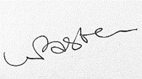
Date: 29/09/2025

Date of next Review Sept 2027

