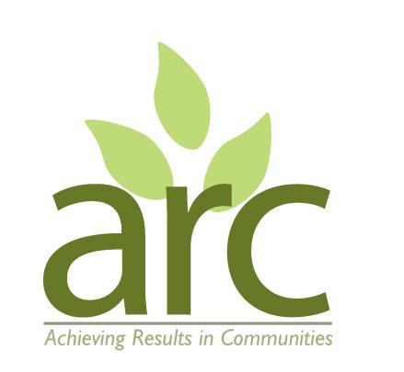
Achieving Results in Communities (ARC)
VOLUNTEER POLICY

Mission
With community-based participation at its heart, the mission of ARC to connect people to one another and with nature, leading to improved mental and physical wellbeing in our local population, and a greater care for our shared natural environment.
Vision
There is mounting evidence that open spaces can make positive contributions to mental and physical health and wellbeing. Open spaces include green spaces and improved urban spaces, e.g. adorned by public art. Helping people to create and sustain such open spaces is empowering for individuals and helps to build stronger communities.
ARC develops and manages natural spaces for people to access and enjoy whilst creating opportunities for people to build a deeper connection with nature and community which contribute positively to mental and physical wellbeing.
Purpose of our volunteer policy
Our volunteer policy has been created to show our volunteers and potential volunteers that we have spent time and care in planning how volunteers will be welcomed with ARC. It also outlines that all volunteers will be treated in a fair and consistent way. It should also help our volunteers understand what support is available to them and what they can expect from us.
Our vision and mission for volunteering
Volunteering is a great way to share your enthusiasm, skills and ideas whilst having fun and meeting like-minded people. By volunteering for ARC you will be making a positive contribution to community development in our area. Volunteers are vital to our work, allowing us to effectively create, transform and maintain green spaces, run events, and reach more people, for example.
Recruitment and Selection
We have a range of opportunities for volunteers to get involved in. Volunteer roles will be advertised in a variety of places including: word of mouth, press and news outlets; ARC and Foundry Wood website and newsletters; social media, WCAVA (Warwickshire Community and Voluntary Action); and through various other outlets from time to time as opportunities arise.
Enquiries and volunteering offers will be dealt with quickly and efficiently, and volunteer placements will match the volunteer’s skills and interests. Volunteers will be treated in line with the ARC’s Equal Opportunities, Diversity and Inclusion Policy.
Some drop-in volunteer roles do not require a form to be completed. Most regular volunteering roles require a volunteer application form to be completed. This helps us to know your expectations and later assess whether we have met them. For sessions where we are working with children or vulnerable people you may also be required to complete a DBS check, and read and sign our Child and Vulnerable Adult Safeguarding Policy and Volunteer Guidelines for Setting and Maintaining Boundaries Procedures.
Volunteers under the age of 16 will be required to fill in a volunteer form with signed parental consent.
Induction and training
Appropriate induction and / or training will be provided to you on site by a project facilitator at the start of your volunteer engagement.
Expenses
Unfortunately we are unable to reimburse expenses apart from special circumstances agreed with the project. Please ask the project facilitator if you would like to be considered for any expenses.
DBS (Disclosure and Baring Service) Checks
Some volunteer roles will be subject to DBS checks and a reference request, e.g. if you will be working with vulnerable adults or children and may spend time with them unaccompanied. This will be made clear when you apply for the role. See also our Child and Vulnerable Adult Safeguarding Policy.
Insurance, health and safety, accidents and risk assessment
ARC has a valid insurance policy so that volunteers are covered by public liability insurance. It covers the volunteering activities you will be doing. We will make you aware of our Health and Safety Policy and Risk Assessments where relevant (these are available on our website at arccic.co.uk/about) and will give simple instructions on how to perform all tasks safely. We have clear procedures for accidents and emergencies and always have a first aider on site.
Resolving problems
We hope that you have an enjoyable experience volunteering with us. However if your role as a volunteer does not meet with your expectations or with the commitments we have made to you, we want you to feel comfortable about letting us know. First of all, talk to the contact person who leads the project or activity you are volunteering with and he or she should be able to resolve any issues. If any issue is not resolved in this way you can contact an ARC Director / follow our Feedback, Compliments and Complaint’s Policy.
Support & Supervision
ARC will:
- Ensure that a named contact person/project facilitator is assigned for supervision and support.
- Be responsible for providing volunteers with appropriate and adequate knowledge, skills, materials and equipment to carry out their role effectively.
- Provide training or guidance for tasks allocated.
Volunteer Rights and Responsibilities:
Volunteer rights:
- To know what is expected and to be given clear information and instruction
- To have clearly specified lines of supervision
- To receive a level of support appropriate to the role
- To receive appropriate induction and training
- To be shown appreciation
- To know what to do if things go wrong
- To have safe working conditions
- To be free of discrimination
- To have the right to say no, and to be able to withdraw from voluntary work
Volunteer Responsibilities
- To fill in a registration form providing your details if requested, and to let ARC know of any changes over time
- To provide references and / or promptly complete DBS forms if requested
- To read and sign the Child and Vulnerable Adult Safeguarding policy and procedures if requested
- To read and comply with additional policies and procedures if requested
- To be reliable, and give a reasonable and sustainable level of commitment
- To be honest and let the project lead know if you encounter any problems.
- To make your way to and from the project location where you are volunteering.
- To take responsibility for your own Health & Safety, e.g. ensure you are suitably clothed for the activities, and have your own refreshments where none are provided by the project.
This policy along with others referenced above can be found on our ARC website at https://arccic.co.uk/about/
It will be reviewed every 2 years.

Name:………………Kath Pasteur………………
Signed:………………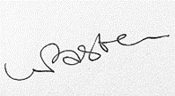………

Date:……………………………29/09/2025… …

Date of next Review Sept 2027

